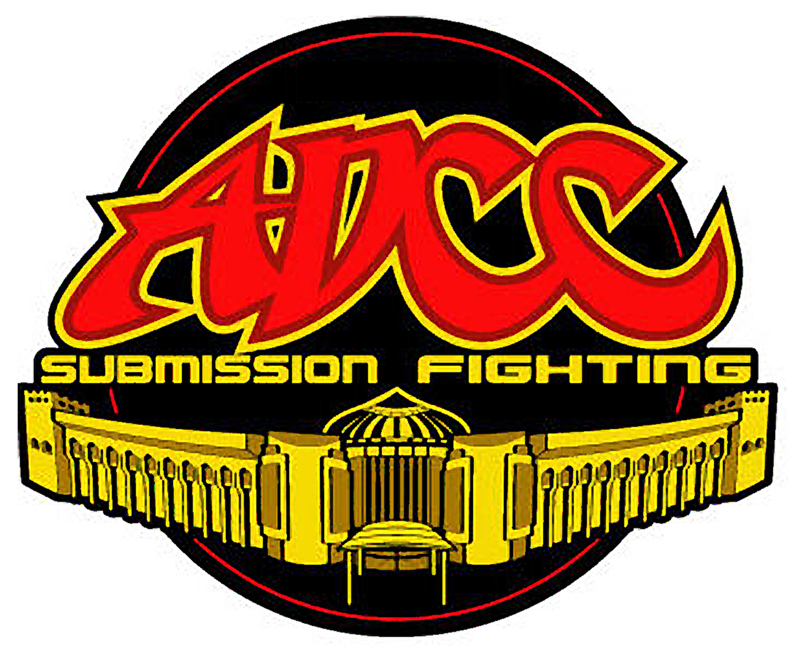
ADCC SUBMISSION FIGHTING
Polish Open 2007

Competition Invitation

Time and Place
December 8th 2007 Skala near Cracow City Poland
City: www.krakow.pl
Info: www.adcc.pl
Bus transportation from the Cracow City to competition place
and back is free – provided by organiser.

Legal Techniques
- Any kind of choke (except for using the hand to close the wind pipe)
with or without the use of the uniform
- Any armbar, shoulder lock, or wrist lock
- Any Leg Lock or Ankle Lock

Illegal Techniques
- No "Full Nelson" or "Crucifix"
- No striking / kicking of any kind
- No eye gouging or fish hooking
- No grabbing the ears
- No hair pulling, biting
- No finger or toe holds
- No thumbing
- No scratching and pinching
- No touching groin area
- No hands, knees or elbows on face
- No slippery substances allowed on body or clothing

Points
2 - Mount position
2 - Knee on stomach
2 - Sweeps (ends Guard or Half Guard)
2 - Takedown (ends Guard or Half Guard)
3 - Back mount with hooks
3 - Passing the guard
4 - Clean sweep (ends passed the guard)
4 - Clean takedown (ends passed the guard)
Lost points
-1 - Go to your back
-1 - Running away

The referee’s decision/judging can’t be overruled!

The winner will be decided according to:
If one competitor gives up or submits by tapping the leg, arm or verbally
If Referee feels one competitor is unable to defend himself or feels his life is in danger,
Referee will declare the winner
If a fighter breaks the rules twice he will be disqualified by the Referee

Ways to win
Submission
Points
Referee’s decision

Fighting Time
6 minutes in ordinary fights (first 3 min without points)
10 minutes in the finales (first 5 min without points)

One Extra rounds are added if fights are even

Weight classes
Men -65.9 kg, -76.9 kg, -87.9 kg, -98.9 kg, + 99 kg, and Absolute class
Female –60kg and +60kg

Equipment
Fighter may use tights, shorts T-shirt, rashgurd or Kimono

Matt
7 x 7 metres tatame

Mat escape, same position as the fighter were in when they crossed the mat line or referee say “stop”

Prizes
Every weight classes’ three best fighters get medals, every competitor gets occasional t-shirt, 250 Euro money prize for Absolute Class winner.

Competition payment
20 €

Weight in
In competition place 7:30 – 8:30 a.m.
Information at 9.00 a.m. (rules etc.)
The Competition starts 9:30 a.m.

Public
The doors open half hour before competition.
Entrance is free.

Registration

The deadline of registration is December 01th 2007
Registration: marcin@adcc.pl

Organized by: ADCC Poland

